

CSE 3224

**INFORMATION SYSTEM DESIGN AND SOFTWARE ENGINEERING LAB**

FINAL REPORT

Submitted by

**Samin Shahriar Tokey** | 14-02-04-066

**Biozid Niloy** | 14-02-04-070

**Naimul Haque** | 14-02-04-080

**Sanaul miraj** | 14-01-04-131

Greener Earth

A website on Climate Change

List Of Contents:

Topic page no

1. Executive Summary of Project 2

2. Project Goals 2

3. Requirements And Feasibility Analysis 2

4. Data Flow Diagram 3

5. Use Case Diagram 10

6. ERD Diagram 11

7. Testing result of Greener Earth 13

8. Opportunities of Development 14

9. Benchmarking 15

10. Conclusion 15

11.References 16

**Executive Summary of Project:**

A website dedicated to educate and raise people's awareness for the climate change. A collection of news reports about the environment, global warming, climate change, green living and many more topics, from across the globe, with links to excellent resources explaining the science and evidence for climate change and views of climate scientists. Read the latest healthy debates on environmental concerns, climate change, green living, transport, conservation movements and campaigns.

Most people are ignorant and careless about climate change. Our goal is to reach out to everyone and to inform them about the effects and consequence of climate change.

**Project Goals:**

* A website dedicated to educate and raise people's awareness for the climate change.
* Various topics, from across the globe, with links to excellent resources explaining the science behind climate change.
* Giving people opportunity to create accounts to donate.
* Making people create forums and threads to discuss with others.
* Make people read the latest healthy debates and blogs on environmental concerns, climate change, green living, transport, conservation movements and campaigns.

**Requirements And Feasibility Analysis:**

**Requirement Analysis:**

Requirements analysis involves frequent communication with system users to determine specific feature expectations, resolution of conflict or ambiguity in requirements as demanded by the various users or groups of users.

Requirements of our project:

* Up to date information on Climate Change
* Opportunity to discuss on various topics about climate change
* Various charts and graphs showing the change in climate change over the years
* Opportunity to give ideas and view blogs

**Feasibility Analysis:**

* **Technical Feasibility:**

We will be delivering

* As we are using PHP as server-side language, it will be:
* Reliable
* Compatible with any kind of upgrade.
* And using HTML & CSS to make the interface, gives us:
* Better & attractive design
* We are using MySQL as our primary database which gives us:
* Flexibility and ease of storing various information
* Ease of changing any information
* Robust and secure
* Moreover, we will be using JavaScript and JQuery to make the website more responsive and feature rich.
* **Economic Feasibility:**
* Cost of programmer, debugger, tester
* Cost of server, storage, internet connection
* Cost of full system study
* Salary of operators
* Handling donations properly
* **Operational Feasibility:**
* Create social awareness
* Tackle climate change with the most scientific ways
* Free of cost service with voluntary donation opportunities
* Provide 24-hour access for the users
* Provide a secure and friendly interface for the users
* Fast and reliable server

**Data Flow Diagram:**

A data flow diagram (DFD) is a graphical representation of the flow of data through an information system, modeling its *process* aspects. A DFD is often used as a preliminary step to create an overview of the system without going into great detail, which can later be elaborated. DFDs can also be used for the visualization of data process.

**Notation used in DFD:**

Entity

Process

Data Storage

Data Flow

**Types of Data Flow Diagram:**

1. Context Diagram
2. Level 1 Diagram
3. Level 2 Diagram

**1.Context Diagram(Level 0):**

DFD Level 0 is also called a Context Diagram. It’s a basic overview of the whole system or process being analyzed or modeled. It’s designed to be an at-a-glance view, showing the system as a single high-level process, with its relationship to external entities. It should be easily understood by a wide audience, including stakeholders, business analysts, data analysts and developers.

**Context Diagram of Greener Earth:**

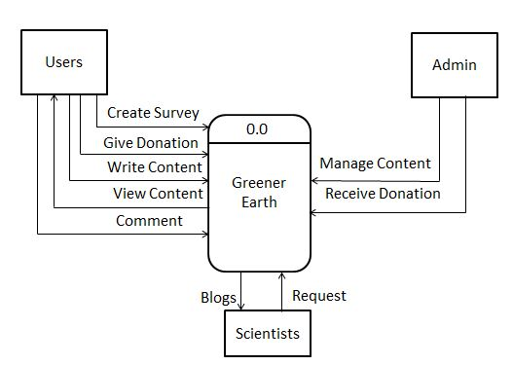

**Description:**

From context diagram we can see that we have three entities in our system. The entities are users, scientists, admin. User can take survey, give donation, write content to the system, view content from the system, comment on contents of the system. Admin can manage all content and receive donation from users. Scientists can post blog on the system, admins will fetch and filter them.

**Level 1 Diagram:**

DFD Level 1 provides a more detailed breakout of pieces of the Context Level Diagram. It highlights the main functions carried out by the system, as it breaks down the high-level process of the Context Diagram into its sub processes.

**Level 1 Diagram of Greener Earth:**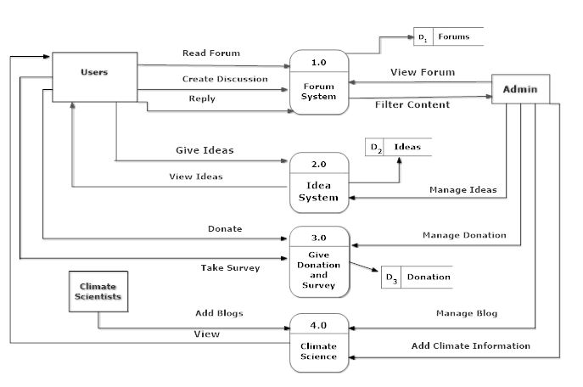

**Description:**

In level 1 diagram we break down the context diagram in several processes. In forum system process, users can create discussion, read forum and reply to the discussion. Admin can view the forum and able to filter the content of the forum. In Idea System process, user can give ideas and view ideas of other users. Admin can manage ideas. In donation and survey system user can donate and take survey. Admin will receive the donation. In Climate Science process, users can view the blogs of scientist. Climate Scientists can add blog and admin can manage the blog and add climate information.

**Level 2 Diagram:**

DFD Level 2 then goes one step deeper into parts of Level 1. It may require more text to reach the necessary level of detail about the system’s functioning.

**Level 2 Diagram of Greener Earth:**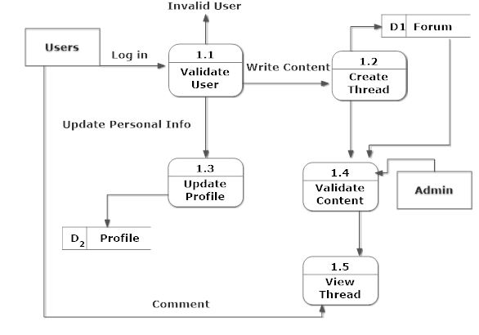

**Description:**

Here validate user process validates the user. After log in user can write content in create thread, update personal info in update profile info process. Users can view the thread and comment on thread.Admin can validate the content.

**Level 2 Diagram of Greener Earth:**

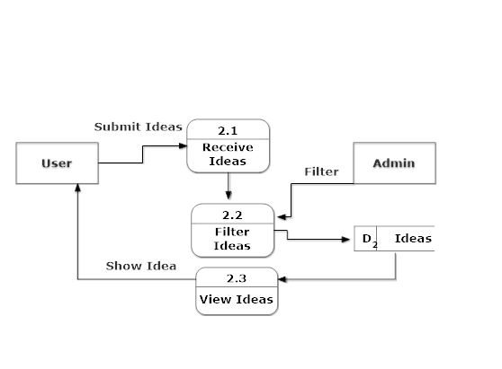

**Description:**

In receive ideas process users can submit the ideas, admin will filter the ideas in filter ideas process. From view ideas process users can view the ideas of other users.

**Level 2 Diagram of the Greener Earth:**

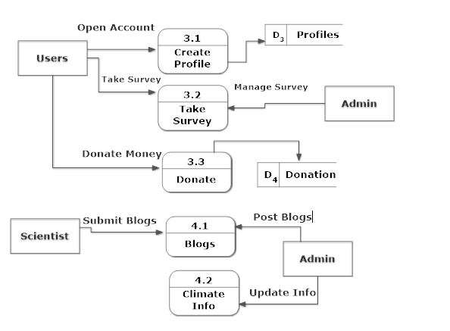

**Description:**

In create profile process user can create the profile. Users can take survey by using take survey process, admin can manage the survey. Users can donate money in donate process. Scientists can submit blogs in blog process and admin will post the blogs. Admin can update climate info by using climate info process.

**Actors:**

* Users :   
  Users will be able to create account , send donations , create forums and take survey. Any user will be able to post ideas without logging in.
* Admins:

Admins will control the control the contents of the page. He will be updating the contents that are taken from scientists, and he will also filter spams.

* Scientist:

Scientists will be contributing indirectly in this website. Admins will fetch and filter contents (Blogs) from scientists and post it in the site.

**Use Case Diagram:**

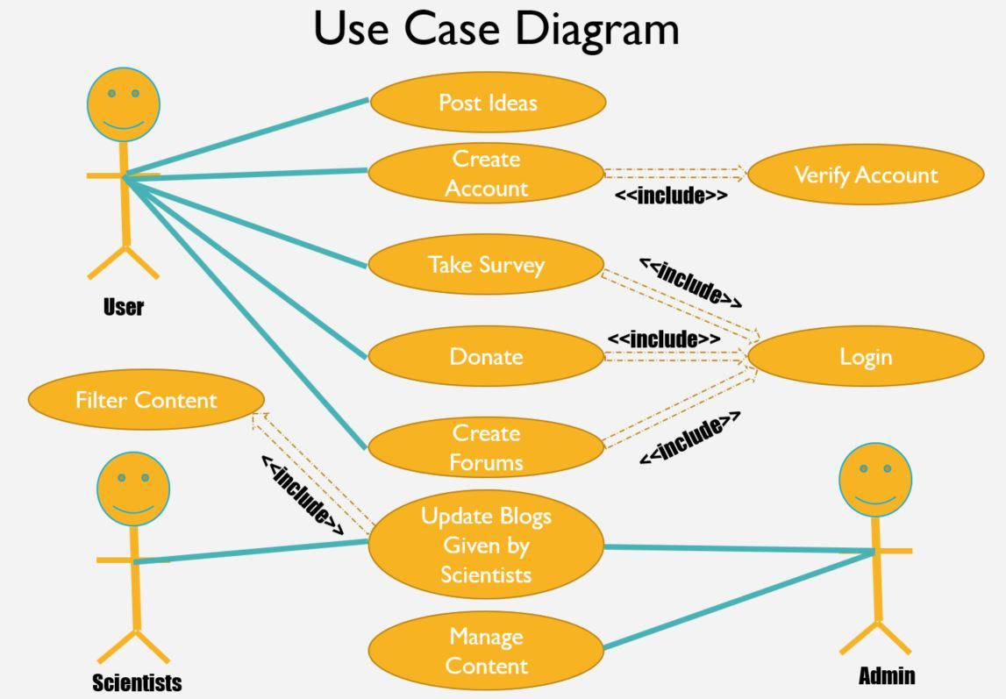

**ERD:**

**ENTITY SET NAMES:**

1. Threads (For creating Forums)

2. Profile (For creating a personalized account for each user)

3. Discussion (Expands under Threads, for discussing on a certain topic)

4. Ideas (Ideas on how to tackle this problem)

5. Survey (User can take a survey on climate change)

Each of the entity has its own attribute depending on its relation with other changes

**ERD Diagram:**

**ATTRIBUTES OF EACH ENTITY:**

**Threads:**

1. heading varchar(5000)

2.headid int(11)

3. user_Id int(11)

4. date datetime

**Profile:**

1. Name varchar(500)

2. Email varchar(500)

3. Password varchar(500)

4. ConfirmPassword varchar(500)

5. Image varchar(500)

6. State varchar(500)

7. ID int(11)

8. Vision varchar(500)

9. totalDonation int(11)

**Discussion:**

1. heading varchar(5000)

2. commId int(11)

3. comment varchar(5000)

4. user_id int(11)

5 . date datetime

**Ideas:**

1. Name int(11)

2. Email varchar(50)

3. Message varchar(5000)

**Survay:**

1. Name varchar(5000)

2. Level varchar(5000)

3. global varchar(5000)

4. evidence varchar(5000)

5. activity varchar(5000)

6. environment varchar(5000)

7. steps varchar(5000)

**Here is the Entity relationship diagram with detailed attributes.**

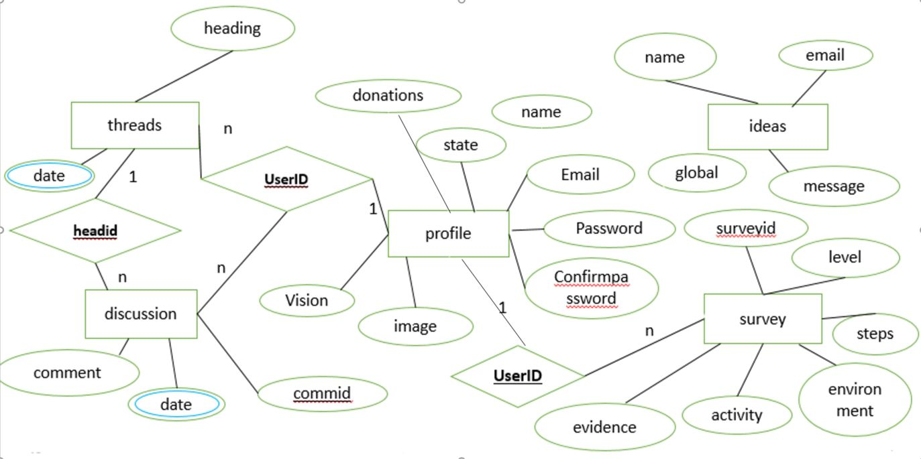

**Explanations:**

This ERD has three relations. One between Threads and Discussion. 1 Thread can have many Discussions. Another relation is between Profile and Survey. Each user can take part in as many survey as he wants. The last relation is between user and Threads. 1 user can create as many threads as he wants. And can discuss through those threads.

However, Ideas is independent, it doesn’t need users to create an account or to log in.

**Testing result of Greener Earth:**

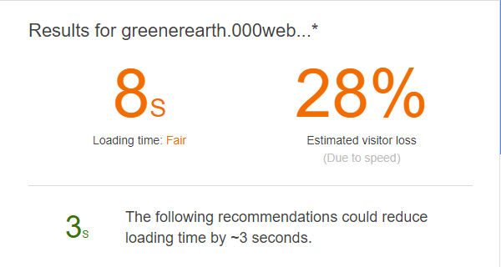

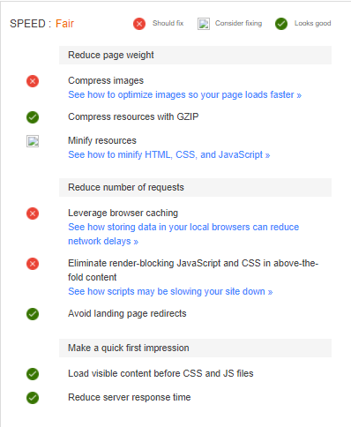

**Opportunities of Development:**

1. **We could have developed a dynamic blog creation system where scientists could add blogs without the interference of the Admin.**
2. **We also could have mark users by scientists and general classification.**
3. **We could have used pie charts and other analysis charts for big data readability.**
4. **We could have taken surveys for different climate topics.**

**Benchmarking:**

**SAMIN SHAHRIAR TOKEY | 14-02-04-066 --- 25%**

**BIOZID NILOY | 14-02-04-070 --- 25%**

**NAIMUL HAQUE | 14-02-04-080 --- 25%**

**SANAUL MIRAJ | 14-01-04-131 --- 25%**

**Conclusion:**

**We have tried our level best to make a successful project happen. We have hosted our website at:** [**https://geenerearth.000webhostapp.com**](https://geenerearth.000webhostapp.com)**. Hope this will be a success.**

**References:**

1. **System Analysis Design 8ED Kendall**
2. **Software Engineering 7th ED Pressman**